A Synopsis on project entitled

**HOPE FOR HUMANITY**

Submitted in partial fulfillment of the requirements for the Award of degree of

**Bachelor of Computer Applications (BCA)**



**HARLAL INSTITUTE OF MANAGEMENT & TECHNOLOGY**

**(Affiliated to CCSU, MEERUT)**

**KNOWLEDGE PARK PHASE-1 GREATER NOIDA**

**Submitted To**: **Submitted By:**

Mr. Narendra Upadhyay Mohd Shoaib (180916106051)

(HOD)

Certificate

We hereby certify that the industrial training project work which is being presented in the project entitled, **“Hope For Humanity”** in partial fulfillment of the requirements for the award of degree of Master Of Computer Applications submitted of Harlal Institute Of Management & Technology, Greater Noida, is an authentic record of our own work carried out at Zephyr Consultants (An unit of  **Future Hope For Slums And Orphans** )

The matter presented in this Project has not been submitted for the award of any other degree of this or any other university.

### (Mohd Shoaib)

This is to certify that the above statement made by the candidates is correct and true to the best of my knowledge.

### Countersigned by

HOD: Mr. Narendra Upadhyay

Program Director

HARLAL INSTITUTE OF MANAGEMENT & TECHNOLOGY KNOWLEDGE PARK PHASE-1, GREATER NOIDA

# DECLARATION

I **Mohd Shoaib,** BCA 6th semester hereby declare that work in the NGO project done by me on the topic “**Hope For Humanity”** as major project**,** is an indigenous piece of work.

### (Mohd Shoaib)

**ACKNOWLEDGEMENT**

This is to certify that the project report entitled “**Hope For Humanity**” which is submitted by us in partial fulfillment of the requirement for the award of degree Bachelor of Computer Applications, Harlal Institute of Management & Technology, Greater Noida, Uttar Pradesh, comprises only our original work.

Date: **_ (Mohd Shoaib)**

# ABSTRACT

## Project Objective: -

Our goal is to create positive and personal differences in the lives of at-risk children so they can achieve productive lives, live with healthy habits and maintain peaceful attitudes toward themselves and others.We do this through teaching essential skills that influence the development of compassion, good choices, positive attitudes and confident minds. Ensure that all at-risk children we reach through our programs and events feel loved and derive skills that support their development and healthy sense of self Be a source of unique empowerment programs that children otherwise would not have. Build healthier communities by investing in the positive development of children. Provide easy and rewarding opportunities for individuals & corporations to give back

## Approach: -

We choose this project the people in those overheard conversations may well be talking about philanthropic trusts and foundations. The reason why they remain a little obscure is because there are so many of them, and they fund a diverse range of activities. As a group, they are hard to come to grips with and hard to keep track of.

We choose Languages HTML, CSS, JAVA, JAVASCRIPT for make it effective and more secure.

## Achievement: -

**“HOPE FOR HUMANITY”** is an NGO to manage **slums, orpahans, and child labor**. Through this project we cover all our theoretical knowledge into practical and we succeed to solve out the problems of managing the healthcare Charity organizations.

# INTRODUCTION

The Project entitled "HOPE FOR HUMANITY" is an NGO website developed in JS language.

The main aim of “HOPE FOR HUMANITY” has to fall into categories that the law says are charitable. These are things like preventing or relieving poverty, or advancing the arts, culture, heritage or science. It has to be established exclusively for what is known as public benefit

Charities may be dedicated to one specific cause or a group of related causes. For example, a charity might aim to improve women's lives by ending rape and domestic violence. Such a charity's objectives might be to establish a crisis line, set up a shelter or educate women about how to stay safe.

Giving to a charity may make you feel good, and also help boost your physical health and mental well-being. Check out these reasons that demonstrate how giving is good for you! Donating is a selfless act. One of the major positive effects of donating money to charity is simply feeling good about giving

The**“HOPE FOR HUMANITY”** act of giving money, food, or other kinds of help to people who are poor, sick, etc. also : something (such as money or food) that is given to people who are poor, sick, etc. : an organization that helps people

Volunteering provides many benefits to both mental and physical health. Volunteering helps counteract the effects of stress, anger, and anxiety. ... Working with pets and other animals has also been shown to improve mood and reduce stress and anxiety. Volunteering combats depression.

**CHARITY HOPE**

**“HOPE FOR HUMANITY”** it is a platform that gives you a better option to help poor people, gave Education Etc Charitable giving is central to Christian spirituality. Christians see everything they have, material and spiritual, as unmerited gifts from God. God gives them to us only because he is generous and wants to bless us. God is even a sacrificial giver

Volunteering allows you to connect to your community and make it a better place. ... And volunteering is a two-way street: It can benefit you and your family as much as the cause you choose to help. Dedicating your time as a volunteer helps you make new friends, expand your network, and boost your social skills.

**PURPOSE OF THIS**

Involvement with your community helps prepare people to become responsible and active citizens, who understand the challenges local people face and work to improve the quality of life through political and non-political processes.

They are established for charitable purposes and to provide donors with a tax deduction for their contributions. They are managed by their own board of directors. They receive most of their financial support from and are normally controlled by their founders.

Non-profits raise money but they spend it to further their mission, not to benefit the donors or founders. They are allowed to pay employees. Non-profit purposes include feeding the homeless, managing an association of businesses and preaching the gospel. The IRS lists more than two dozen types of tax-exempt nonprofits.

# HARDWARE AND SOFTWARE REQUIREMENTS

### HARDWARE :

PROCESSOR: PENTIUM II OR HIGHER. HARD DISK: 1 TB

RAM: 8 GB

### SOFTWARE :

FRONT END: HTML, CSS, JAVASCRIPT

OPERATING SYSTEM: WINDOWS

# DATA FLOW DIAGRAM

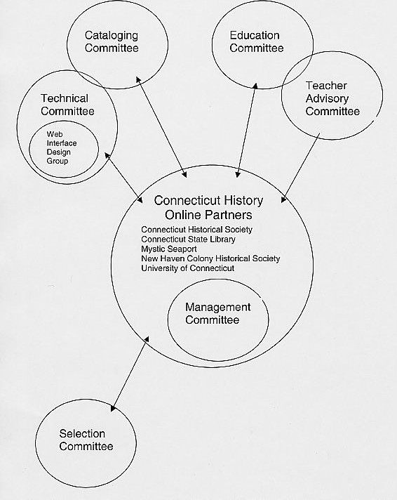

**ENTITY RELATIONSHIP DIAGRAM**

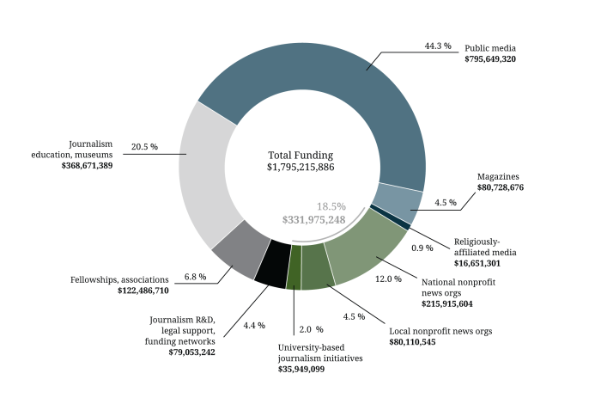

**CONCLUSION & FUTURE SCOPE**

Nothing is perfect in the world. So, Scope is a national disability charity that campaigns to challenge and change negative attitudes about disability and provides direct services. The Organization was founded in 1952 by a group of parents and social workers who wanted to ensure that their disabled children had the right to a decent education.

They found that while NGO projects reach the poor people, they tend not to reach down to the very poorest. NGO projects also tend to be small scale. ... NGOs through the micro-finance help members of community to access jobs, income-generation and improve economic situation there by alleviating poverty from the poor.